**Practical No. 1**

**Enrollment No.: 23becse54008**

**֍ Aim:**

**Design web pages for your college containing a description of the courses, departments, faculties, and library Use Href and list tags**.

**Program:**

<html>

<head>

<title> VSITR College Management system </title>

</head>

<center>

<body>

<img src="Capture.jpg";>

<p><b>----WELCOME TO VSITR-KADI </b></p>

<p>**AN AICTE APPROVED CONSTITUENT INSTITUTE OF KADI SARVA VISHWAVIDYALAYA**</p>

<img src="FRONT.jpg";>

<p><b>EDUCATION EXCELLENCE SINCE GENERATION</p>

<a style="background-color:yellow">VSITR IS BACKED WITH OLDEST EDUCATION LEGECY IN GUJARAT</a>

<p>Vidush Somany institute of Technology & Research is managed by Sarva Vidyalaya Kelavani Mandal,<br>

which is operational in providing affordable and world class education for all since 1919.<br>

Also the Kadi Sarva Vishwavidyalaya University is one of the largest private university in Gujarat offering varieties<br>

of academic courses at different levels.</p>

<h2>ABOUT US</h2>

<p><b>INTERNATIONAL COLLABORATION</b></p>

<a style="background-color:yellow">PROVIDING WORLD CLASS EDUCATION AT DOORSTEP</a>

<p>University has signed MOU with Florida Atlantic University,<br>

USA for its Education discipline, University has also received three times delegation from<br>

Georgian College and has signed MOU with Georgian College, Canada for Precision Skill Programme with<br>

Engineering College. Kadi Sarva Vishwavidyalaya also visited by delegates from University of Alberta,<br>

having world Ranking 69 for its Management Programme and expect Doctoral research and student exchange <br>

programme with the same </p>

<img src="kadi1.jpg";>

<h2>DEPARTMENTS </h2>

Computer Engineering <br> Mechanical Engineering<br> Civil Engineering<br> Information and Technology<br>

Information and Communication Technology<br>

</body>

</center>

</html>

**Output:**



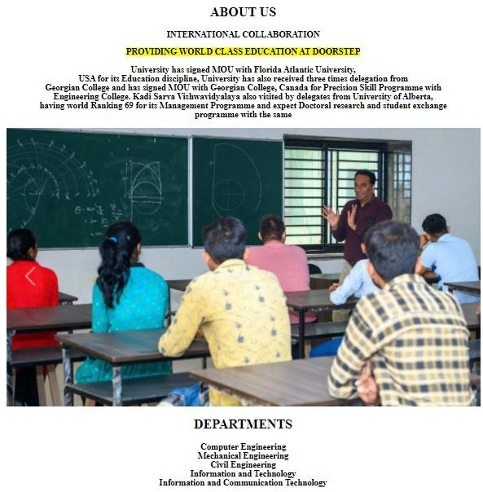

**Practical No. 2**

**Enrollment No.: 23becse54008**

**֍ Aim:**

**Create your class timetable using table tag.**

**Program:**

<html>

<head>

<title>practical 2</title>

</head>

<body style="background-color:silver;">

<center>

<table>

<h1>VIDUSH SOMANY INSTITUTE OF TECHNOLOGY AND RESEARCH,KADI</h1><br/>

<a style="color:red;">TIME TABLE</a> for <a style="color:red;">SEMESTER-3</a>

<br/><br/>

<a style="color:green;">BE-G3</a>

<br/><br/>

<table border=2>

<tr>

<td></td>

<td>Monday</td>

<td>Tuesday</td>

</tr>

<tr>

</tr>

<tr>

</tr>

<tr>

</tr>

<tr>

<td>Wednesday</td>

<td>Thursday</td>

<td>Friday</td>

<td>11:00am to 11:50am</td>

<td>DBMS(JGP)</td>

<td></td>

<td>DE(AJP)</td>

<td>DSA(HBP)</td>

<td>DBMS(DA)</td>

<td>11:55am to 12:45pm</td>

<td style="background-color:yellow">DM(VKP)</td>

<td>DSA(HBP)</td>

<td style="background-color:yellow">DM(KJ)</td>

<td>DE(JP)</td>

<td style="background-color:yellow">DM(VKP)</td>

<td>12:45pm to 1:20pm</td>

<td colspan="5" style="text-align:center">BREAK</td>

<td>1:20pm to 2:10pm</td>

<td>DE(JP)</td>

<td style="background-color:yellow">DM-TUT(KJ/VKP)</td>

<td>ITW(MJP)</td>

</tr>

<tr>

</tr>

<tr>

</tr>

<tr>

</tr>

<tr>

<td>DSA(HBP)</td>

<td></td>

<td>2:15pm to 3:00pm</td>

<td>DE(JP)</td>

<td>ITW(KMJ)</td>

<td></td>

<td>DSA(HBP)</td>

<td></td>

<td>3:00pm to 3:15pm</td>

<td colspan="5" style="text-align:center">BREAK</td>

<td>3:15pm to 4:10pm</td>

<td>DBMS(JGP)</td>

<td rowspan="2">DSA(HBP)</td>

<td rowspan="2">ITW(KMJ)</td>

<td rowspan="2">DE(JP)</td>

<td rowspan="2">DBMS(DA)</td>

</tr>

<td>4:10pm to 5:00pm</td>

<td>DBMS(JGP)</td>

</table>

</center>

</body>

</html>

**Output:**

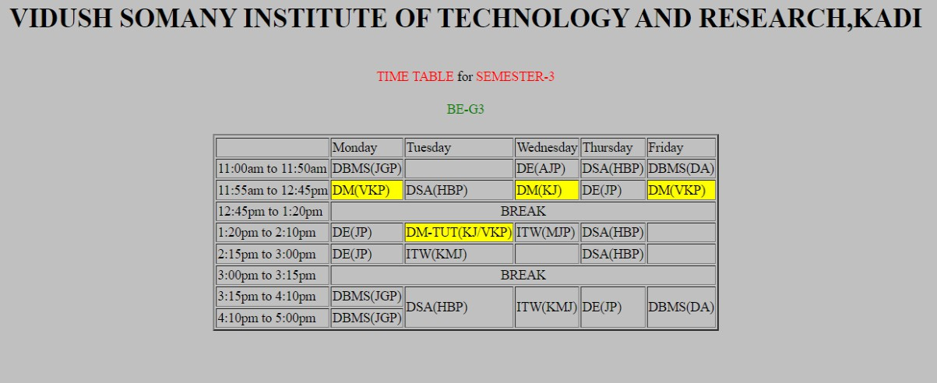

**Practical No. 3**

**Enrollment No.: 23becse54008**

**֍ Aim:**

**Create user Student feedback form (use textbox, text area, checkbox, radio button, select box etc.)**

**Program:**

<html>

<head>

<title>20BEIT54057_Practical 3</title>

</head>

<body bgcolor="#AED6F1">

<H1><FONT COLOR="black"><CENTER><u><b>STUDENT FEEDBACK

FORM</u></b></H1>

<form>

<table border="3" cellspacing="10" align="center">

<tr>

<td >

<label for="fname"><font color="black"><b>First name:</b></label><br>

<input type="text" placeholder="Enter First

name" id="fname" name="fname"><br>

</td>

</tr>

<tr>

<td>

<label for="lname"><font color="black"><b>Last name:</b></label><br>

name" id="lname" name="lname"><br>

</td>

<input type="text" placeholder="Enter Last

</tr>

<tr>

<td>

<label for="Enr Number"><font

color="black"><b>Enrollment Number:</b></label><br>

<input type="text" placeholder="Enter Enrollment Number" id

="Enr Number" name="Enr Number"><br>

</td>

</tr>

<tr>

<td>

<label for="Enr Number"><font

color="black"><b>Select Your Hobby:</b></label><br>

<input type="checkbox" name="Reading">

<label for="Branch"><font

color="black"><b>Reading</b></label>

color="black"><b>Singing</b></label>

color="black"><b>Others</b></label><br>

</td>

<input type="checkbox" name="Singing">

<label for="Branch"><font

<input type="checkbox" name="Playing">

<label for="Branch"><font

</tr>

<tr>

<td>

<label for="Email Id"><font

color="black"><b>Email Id:</b></label><br>

Id" id="Email Id" name="Email Id"><br>

</td>

<input type="text" placeholder="Enter Email

</tr>

<tr>

<td>

<label for="Enr Number"><font

color="black"><b>Select Your Branch:</b></label><br>

<input type="radio" id="Branch"

name="Branch" value="CE"> color="black"><b>CE</b></label><br> name="Branch" value="CSE"> color="black"><b>CSE</b></label><br> name="Branch" value="IT">

color="black"><b>IT</b></label><br>

</td>

<label for="CE"><font

<input type="radio" id="Branch"

<label for="CSE"><font

<input type="radio" id="Branch"

<label for="Branch"><font

</tr>

<tr>

<td>

<label for="feedback"><font

color="black"><b>Your Feedback:</b></label><br>

<textarea id="Feedback" placeholder="Enter your Feedback For This college and Your Faculty " name="feedback" rows="4" cols="50"></textarea><br>

</tr>

<tr>

</td>

<td align="center">

</tr>

</table>

</form>

</body>

</html>

**Output:**

</td>

<input type="submit" value="Submit">

<input type="reset" name="reset">

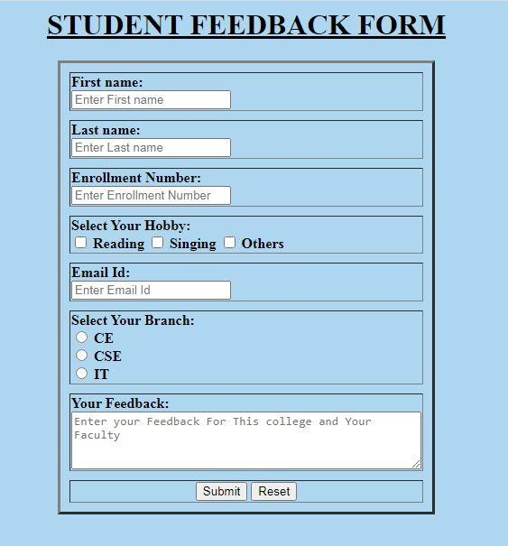

**Practical No. 4**

**Enrollment No.: 23becse54008**

**֍ Aim:**

**Create a web page using frame. Divide the page into two parts with Navigation links on left hand side of page (width=20%) and content page on right hand side of page (width = 80%). On clicking the navigation Links**

**corresponding content must be shown on the right hand side.**

**Program:**

**Index.html**

<html>

</html

<head>

<title>20BEIT54057_PRACTICAL 4</title>

</head>

<frameset cols="20%,*">

<frame src="menu.html" noresize />

<frame name="main_cont" src="Home.html"/>

</frameset>

**menu.html**

<html>

<head>

<title>20BEIT54057_PRACTICAL 4</title>

</head>

<body bgcolor="orange">

<table border="1" cellspacing="5" align="auto">

<tr>

<td>

<b><a href="Home.html"

target="main_cont">Home</a><br></b>

</td>

</tr>

</table><br>

<table border="1" cellspacing="5" align="auto">

<tr>

<td>

<b><a href="Department.html"

target="main_cont">Department</a><br></b>

</td>

</tr>

</table><br>

<table border="1" cellspacing="5" align="auto">

<tr>

<td>

<b><a href="Faculties.html"

target="main_cont">Faculties</a><br></b>

</td>

</tr>

</table><br>

<table border="1" cellspacing="5" align="auto">

<tr>

<td>

<b><a href="Contect Us.html"

target="main_cont">Contect Us</a><br></b>

</td>

</tr>

</table><br>

</body>

</html>

**Home.html**

<html>

<head>

<title>20BEIT54057_PRACTICAL 4</title>

</head>

<body bgcolor="white">

<h1 style="font-size: 80px;margin: 0" align="center">WELCOME TO VSITR

KADI</h1>

<h2>AN AICTE APPROVED CONSTITUENT INSTITUTE OF KADI SARVA

VISHWAVIDYALAYA</h2>

<img style="margin-top: 10%" [src="h](http://www.vsitr.ac.in/wp-)ttp:/[/www.vsitr.ac.in/wp-](http://www.vsitr.ac.in/wp-) content/uploads/2019/06/home3.jpg">

<h2 style="margin-left: 57%;margin-top: -33%"> EDUCATION EXCELLENCE SINCE GENERATIONS<br> VSITR IS BACKED WITH OLDEST EDUCATION LEGECY IN GUJARAT<br>

Vidush Somany institute of Technology & Research is managed by Sarva Vidyalaya Kelavani Mandal, which is operational in providing

affordable and world class education for all since 1919. Also the Kadi Sarva Vishwavidyalaya University is one of the largest private

university in Gujarat offering varieties of academic courses at different

levels.</h2>

<img style="margin-top: 10%; margin-left: 45%;"s[rc="h](http://www.vsitr.ac.in/wp-content/uploads/2019/06/home4.jpg)ttp:[//www.vsitr.ac.in/wp-content/uploads/2019/06/home4.jpg](http://www.vsitr.ac.in/wp-content/uploads/2019/06/home4.jpg)">

<h2 style="margin-right: 57%;margin-top: -33%"> INTERNATIONAL COLLABORATION<br>

PROVIDING WORLD CLASS EDUCATION AT DOORSTEP<br>

University has signed MOU with Florida Atlantic University, USA for its Education discipline, University has also received three times

delegation from Georgian College and has signed MOU with Georgian College, Canada for Precision Skill Programme with

Engineering College. Kadi Sarva Vishwavidyalaya also visited by delegates from University of Alberta, having world Ranking 69 for

its Management Programme and expect Doctoral research and student exchange programme with the same .</h2>

</body>

</html>

**Department.html**

<html>

<head>

<title>20BEIT54057_PRACTICAL 4</title>

</head>

<body bgcolor="powderblue">

<header style="text-align: center;">

<i><b><u><h1 align="center"

style="color:blue;">DEPARTMENT</h1></u></b></i>

<h2 style="color:blue;"><li><i><b>CE DEPARTMENT</h2></b></i></li>

<h2 style="color:blue;"><li><i><b>IT DEPARTMENT</h2></b></i></li>

<h2 style="color:blue;"><li><i><b>CSE DEPARTMENT</h2></b></i></li>

<h2 style="color:blue;"><li><i><b>ME DEPARTMENT</h2></b></i></li>

<h2 style="color:blue;"><li><i><b>CIVIL DEPARTMENT</h2></b></i></li>

</header><br/>

</body>

</html>

**Faculties.html**

<html>

<head>

<title>20BEIT54057_PRACTICAL 4</title>

</head>

<body bgcolor="#01DFD7">

<img s[rc="h](http://www.vsitr.ac.in/wp-content/uploads/2019/06/vsitr11-)ttp:[//www.vsitr.ac.in/wp-content/uploads/2019/06/vsitr11-](http://www.vsitr.ac.in/wp-content/uploads/2019/06/vsitr11-)

01.png" width="800" height="142"><br/>

<u><b><h1> Principal Of Vidush Somany Institute Of Tecnology & Research</h1></b></u>

<i><b><h1>Dr.hiren B. Patel</h1></b></i><br/>

<img s[rc="h](http://www.vsitr.ac.in/wp-)ttp:[//www.vsitr.ac.in/wp-](http://www.vsitr.ac.in/wp-) content/uploads/2019/07/HBPatel.jpg">

<header>

<b><i><h3>Since July 2019, Prof. (Dr) Hiren B. Patel has beenworking as Principal at Vidush Somany Institute of Technology

and Research (www.vsitr.ac.in), a constituent institute of Kadi Sarva Vishwavidyalaya, under the aegis of Sarva Vidyalaya

Kelavani Mandal. He had been associated as Professor & Head in ComputerEngineering Department at LDRP Institute of

Technology & Research (www.ldrp.ac.in), Gandhinagar from January-2017 to June-2019. Before joining LDRP-ITR, he worked

for S. P. College of Engineering (www.spcevng.ac.in) as Professor

and Head of

He

Computer/IT Department for more than 11 years. He also acted as Incharge Principal at the institute. He was also a Dean – Faculty of Computer Science at Sankalchand Patel University (www.spu.ac.in) and Chairman, Board of Studies for Computer Engineering & Information Technology. He was also Chairman, BoS for Computer Engineering at North Gujarat University Patan ([http://ngu.ac.in/).](http://ngu.ac.in/))

completed his Ph.D. (Computer Engineering) from National Institute

of Technology (NIT), Surat with Cloud Computing as the major domain for research, Post-Graduation (M.E. with specialization in Microprocessors) from M. S. University and graduation (B.E. – Computer Engineering) from Sardar Patel University (BVM). Having around 22 years of experience, he has more than 60 research papers in various conferences & journals of national and international repute. One of his papers has been awarded as Elsevier’s best paper award. He has successfully supervised two Ph.D. candidates. Apart from delivering numerous expert talks at the various organization, he has also spared his services to IIT, Gandhinagar as a guest faculty for two semesters. He also acted as reviewer & session chairs for many conferences. Few of his main subjects of interest are Cloud Computing, Parallel Programming, Computer Networking, Research Methodology, Information Security, Technical Communication, IoT and Blockchain. He spared his services at Gujarat Technological University as Subject Expert

& VC Nominee for Interviews, Co-chair academic for Mehsana

Sankul, Member of Board of Sport & Cultural, Member of Gujarat Technological University (GTU) Alumni Association, Member GTU’s NSS Advisory Board. He has delivered numerous expert talks at

with her at</a>

various institutes.<br/>

<a href[="p](mailto:principal@vsitr.ac.in)ri[ncipal@vsitr.ac.in](mailto:principal@vsitr.ac.in)">For more details, please correspond

</h3></i></b>

</header>

</body>

</html>

**Contact Us.html**

<html>

<head>

<title>20BEIT54057_PRACTICAL 4</title>

</head>

<body bgcolor="#01DFD7">

<img s[rc="h](http://www.vsitr.ac.in/wp-content/uploads/2019/06/vsitr11-)ttp:[//www.vsitr.ac.in/wp-content/uploads/2019/06/vsitr11-](http://www.vsitr.ac.in/wp-content/uploads/2019/06/vsitr11-)

01.png" width="800" height="142">

<header style="text-align: center;">

<b><u><h1 style="color:blue;">CONTACT US</h1></u></b>

<b><h3><a href="https://goo.gl/maps/Ta1n5vF2uhVoZWji8">FIND OUR COLLEGE IN MAP<br/>

PLEASE CLICK HEAR</a></h3></b>

<b><u><h1 style="color:blue;">TALK TO US</h1></u></b>

<b><u><h2 style="color:black;">Call: +91 9328 007

815</h2></u></b>

062</h2></u></b>

<b><u><h2 style="color:black;">Mob: +91 9328 029

<b><u><h1 style="color:blue;">OUR LOCATION</h1></u></b>

<b><u><h2 style="color:black;">Near Railway Station,

Kadi.<br/>Gandhinagar, Gujarat</h2></u></b>

</header>

</body>

</html>

**Output:**



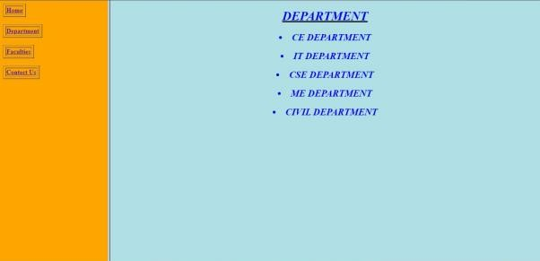





**Practical No. 5**

**Enrollment No.: 23becse54008**

**֍ Aim:**

**Create your resume using HTML tags also experiment with colors, text, link , size and also other tags you studied.**

**Program:**

<html>

<head>

<title>20BEIT54057_PRACTICAL 5</title>

</head>

<body bgcolor="#AED6F1">

<H1><FONT COLOR="black"><CENTER><u><b>RESUME</u></b></H1>

<table border="3" cellspacing="10" align="center">

<tr>

SHEKHDA</h1></b>

<td >

<font color="black"><b><h1>AKSHIT

[Akshit1000@gmail.com<](mailto:Akshit1000@gmail.com)/h2></b>

</td>

<font color="black"><b><h2>Email :

</tr>

<tr>

<td>

<font

color="black"><h1><u><b>Interests:</b></u></h1>

<ul>

<font color="red"><h2><b><li>Cricket</li></h2></b>

<font color="red"><h2><b><li>Photography</li></h2></b>

<font color="red"><h2><b><li>Eating</li></h2></b>

<font color="red"><h2><b><li>Programming</li></h2></b>

<font color="red"><h2><b><li>Computer

Science</li></h2></b>

</ul>

</tr>

<tr>

</td>

<td>

<font

color="black"><h1><b><u>Skills</b></u></b></h1>

<ul>

with HTML & CSS</li></b></h2>

skills</li></b></h2>

</ul>

<ul>

</ul>

<font color="black"><h2><b><li>Web Design

<font color="black"><h2><b><li>Good Logical

</tr>

<tr>

</td>

<td>

<font

color="black"><h1><u><b>Education</b></u></h1>

<ul>

<font color="black"><h2><b><a href="https://[www.adanividyamandir.org/](http://www.adanividyamandir.org/)">

<font color="black"><li>Adani Vidya

Mandir</li>

href[="h](http://www.vsitr.ac.in/)tt[p://www.vsitr.ac.in/](http://www.vsitr.ac.in/)">

</a></b></h2>

<font color="black"><h2><b><a

<font color="black"><li>VIDUSH SOMANY INSTITUTE OF TECHNOLOGY AND RESEARCH</li>

</a></h2></b>

</ul>

</td>

</tr>

</table>

</body>

</html>

**Output:**

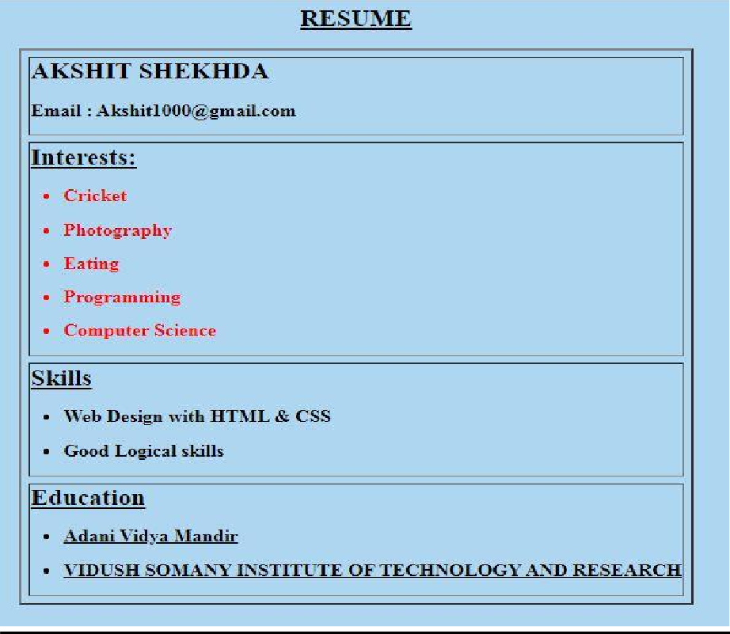

**Practical No. 6**

**Enrollment No.: 23becse54008**

**֍ Aim:**

**Design a web page of your home town with an attractive background color, text color, an Image, font etc. (use internal CSS).**

**Program:**

<html>

<head>

<title>Home Town</title>

</head>

<style>

body{

**}**

h1

**{**

**}**

width: 1500px; height: 200px; border: 2px solid; color: light blue;

font-size: 90px; text-align: center;

p

**{**

font-size: 50px;

**}**

h3

**{**

**}**

.btn {

**}**

p

**{**

**}**

</style>

font-weight: bold; color: green;

text-align: center;

font-size: 30px; color:blue;

text-align: center; border: 1;

padding: 14px 28px; font-size: 30px; cursor: pointer; display: inline-block;

color: red;

font-size: 30px; font-weight: bold;

<body>

<div class="tiledBackground">

</div><h1>Gandhinagar</h1>

<center><p>#GreenCity</p></center>

<p>

<img src=”download.jpg”/>

Gandhinagar is a planned city in the western Indian state of Gujarat.

The Akshardham is a massive Hindu temple with ornate carvings and sculpted pillars, plus a water show in its sprawling gardens.

Dandi Kutir museum traces the life of leader Mahatma Gandhi, who was born in Gujarat.

the Indroda Nature Park has a zoo and botanical gardens, plus an adjacent dinosaur and fossil park

</p>

<h3>Famous Things in Gandhinagar</h3>

<div class="btn">

<a href="p.html"><button class="btn">Greenary</button></a>

<a href="t.html"><button class="btn">Akshardham Temple</button></a>

<a href="s.html"><button class="btn">Dandi Kutir</button></a>

<a href="g.html"><button class="btn">Indroda Park</button></a>

</div>

</body>

</html>

**Output:**

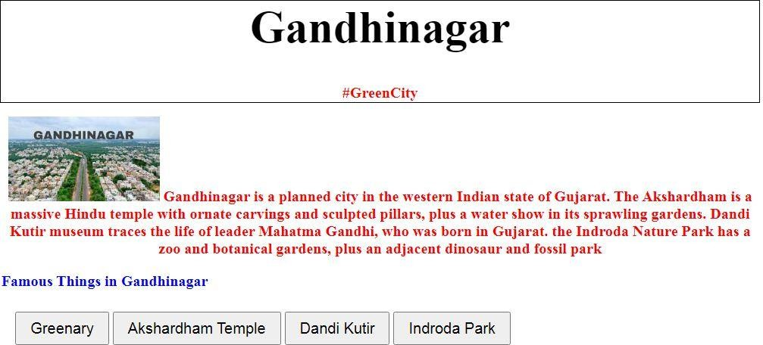

**Practical No. 7**

**Enrollment No.: 23becse54008**

**֍ Aim:**

**Use Inline CSS to format your resume that you created.**

**Program:**

<html>

<head>

<title>20BEIT54057</title>

</head>

<body bgcolor="#AED6F1">

<H1><FONT COLOR="black"><CENTER><u><b>RESUME</u></b></H1>

<table border="3" cellspacing="10" align="center">

<tr style="background-color:red">

<td >

SHEKHDA</h1></b>

[akshit1000@gmail.com<](mailto:akshit1000@gmail.com)/h2></b>

</td>

<font color="pink"><b><h1>AKSHIT

<font color="black"><b><h2>Email :

</tr>

<tr>

<td>

<font

color="black"><h1><u><b>Interests:</b></u></h1>

<ul>

<font color="yellow"><h2><b><li>Cricket</li></h2></b>

<font color="brown"><h2><b><li>Photography</li></h2></b>

<font color="grey"><h2><b><li>Design</li></h2></b>

<font color="purple"><h2><b><li>Programming</li></h2></b>

<font color="black"><h2><b><li>Computer

Science</li></h2></b> </ul>

</tr>

<tr>

</td>

<td>

<font

color="black"><h1><b><u>Skills</b></u></b></h1>

<ul>

with HTML & CSS</li></b></h2>

CODING</li></b></h2>

</ul>

<ul>

</ul>

<font color="black"><h2><b><li>Web Design

<font color="black"><h2><b><li>COMPETETIVE

</td>

</tr>

<tr style="background-color:green">

<td>

<font color="black"><h1><u><b>Education</b></u></h1>

<ul>

<font color="black"><h2><b><a href="https://[www.adanividyamandir.org/](http://www.adanividyamandir.org/)">

<font color="black"><li>Adani Vidya

Mandir</li>

href[="h](http://www.vsitr.ac.in/)tt[p://www.vsitr.ac.in/](http://www.vsitr.ac.in/)">

</a></b></h2>

<font color="black"><h2><b><a

<font color="black"><li>VIDUSH SOMANY INSTITUTE OF TECHNOLOGY AND RESEARCH</li>

</a></h2></b>

</td>

</tr>

</table>

</body>

</html>

**OUTPUT:**

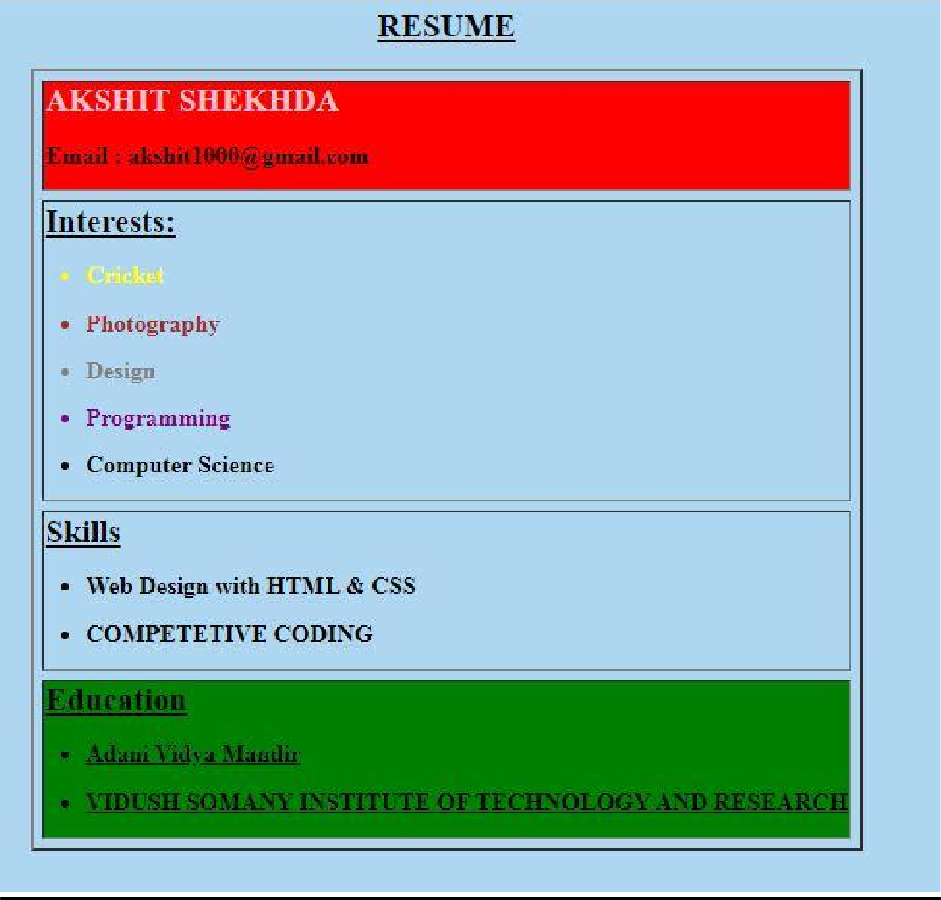

**Practical No. 8**

**Enrollment No.: 23becse54008**

**֍ Aim:**

**Use External CSS to format your class timetable as you created**

**Program:**

<html>

<head>

<title>practical 2</title>

<link rel="stylesheet" href="style1.css">

</head>

<body>

<center>

<table>

<h1>VIDUSH SOMANY INSTITUTE OF TECHNOLOGY AND RESEARCH,KADI</h1><br/>

<a>TIME TABLE</a> for <a>SEMESTER-3</a>

<br/><br/>

<a>BE-G3</a>

<br/><br/>

<table border=2>

<tr>

<td></td>

<td>Monday</td>

<td>Tuesday</td>

</tr>

<tr>

</tr>

<tr>

</tr>

<tr>

</tr>

<tr>

<td>Wednesday</td>

<td>Thursday</td>

<td>Friday</td>

<td>11:00am to 11:50am</td>

<td>DBMS(JGP)</td>

<td></td>

<td>DE(AJP)</td>

<td>DSA(HBP)</td>

<td>DBMS(DA)</td>

<td>11:55am to 12:45pm</td>

<td style="background-color:yellow">DM(VKP)</td>

<td>DSA(HBP)</td>

<td style="background-color:yellow">DM(KJ)</td>

<td>DE(JP)</td>

<td style="background-color:yellow">DM(VKP)</td>

<td>12:45pm to 1:20pm</td>

<td colspan="5" style="text-align:center">BREAK</td>

<td>1:20pm to 2:10pm</td>

<td>DE(JP)</td>

<td style="background-color:yellow">DM-TUT(KJ/VKP)</td>

<td>ITW(MJP)</td>

</tr>

<tr>

</tr>

<tr>

</tr>

<tr>

</tr>

<tr>

<td>DSA(HBP)</td>

<td></td>

<td>2:15pm to 3:00pm</td>

<td>DE(JP)</td>

<td>ITW(KMJ)</td>

<td></td>

<td>DSA(HBP)</td>

<td></td>

<td>3:00pm to 3:15pm</td>

<td colspan="5" style="text-align:center">BREAK</td>

<td>3:15pm to 4:10pm</td>

<td>DBMS(JGP)</td>

<td rowspan="2">DSA(HBP)</td>

<td rowspan="2">ITW(KMJ)</td>

<td rowspan="2">DE(JP)</td>

<td rowspan="2">DBMS(DA)</td>

</tr>

<td>4:10pm to 5:00pm</td>

<td>DBMS(JGP)</td>

</table>

</center>

</body>

</html> Style1.css: h1{ color:red;

**}**

a{ color:green;

**}**

**Output:**

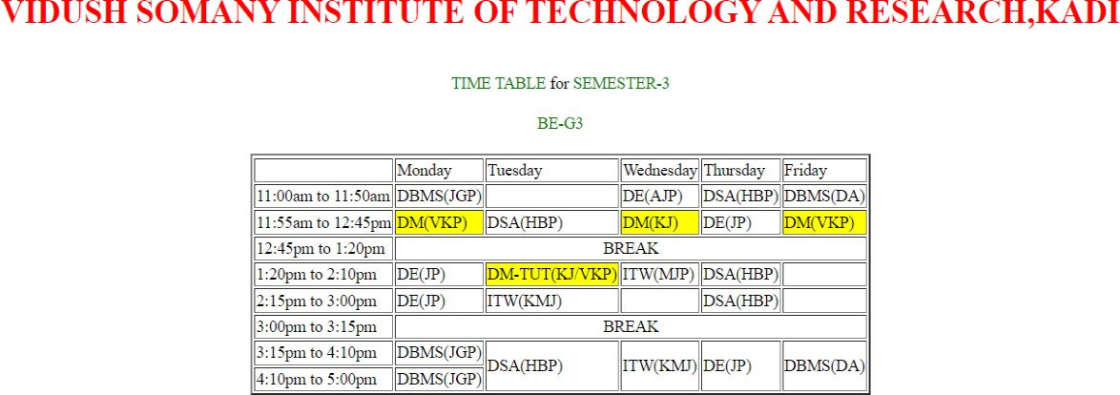

**Practical No. 9**

**Enrollment No.: 23becse54008**

**֍ Aim:**

**Use External, Internal, and Inline CSS to format college web page that you created**

**Program:**

**INDEX.HTML**

<html>

<head>

<title>20BEIT54057_PRACTICAL 9</title>

<link rel="stylesheet" type="text/css" href="style.css">

</head>

<body>

<header>

<div class="main">

<nav>

<div class="logo">

<img s[rc="h](http://www.vsitr.ac.in/wp-)ttp:[//www.vsitr.ac.in/wp-](http://www.vsitr.ac.in/wp-)

content/uploads/2019/06/vsitr11-01.png">

</div>

<ul>

<li class="active"><a href="#">HOME</a></li>

<li><a href="#">COURSES</a></li>

<li><a href="#">DEPARTMENTS</a></li>

<li><a href="#">FACULTIES</a></li>

<li><a href="#">CONTACT US</a></li>

</ul>

</div>

<div class="title">

<h1><b>INSPIERD BY GLOBAL EDUCATION</h1></b>

</div>

<div class="one">

<h2><b>ENGINEERING WITH INTERNATIONAL EXPOSURE</b></h2>

</div>

</nav>

</header>

<h1 style="font-size: 50px;margin: 0" align="center">WELCOME TO

VSITR KADI</h1>

<h2 align="center">AN AICTE APPROVED CONSTITUENT INSTITUTE

OF KADI SARVA VISHWAVIDYALAYA</h2>

<img style="margin-top: 2%" [src="h](http://www.vsitr.ac.in/wp-)ttp:/[/www.vsitr.ac.in/wp-](http://www.vsitr.ac.in/wp-) content/uploads/2019/06/home3.jpg">

<h2 style="margin-left: 45%;margin-top: -25%">EDUCATION EXCELLENCE SINCE GENERATIONS<br>

VSITR IS BACKED WITH OLDEST EDUCATION LEGECY IN GUJARAT<br>

Vidush Somany institute of Technology & Research is managed by Sarva Vidyalaya Kelavani Mandal, which is operational

in providinG affordable and world class education for all since 1919.

Also theKadi Sarva Vishwavidyalaya University is one

of the largest private university in Gujarat offering varieties of academic courses at different levels.</h2>

<b class="btn"><a href="#">Contact Us</a></b>

<img style="margin-top: 10%; margin- left:57%;"s[rc="h](http://www.vsitr.ac.in/wp-content/uploads/2019/06/home4.jpg)ttp:[//www.vsitr.ac.in/wp-content/uploads/2019/06/home4.jpg](http://www.vsitr.ac.in/wp-content/uploads/2019/06/home4.jpg)"><br>

<h2 style="margin-right: 47%; margin-left: 1%; margin-top:- 25%">INTERNATIONAL COLLABORATION<br>

PROVIDING WORLD CLASS EDUCATION AT DOORSTEP<br>

University has signed MOU with Florida Atlantic University, USA for

</div>

</body>

</html>

its Education discipline, University has also received three times delegation from Georgian College and has signed MOU with Georgian College, Canada for Precision Skill Programme with Engineering College. Kadi Sarva Vishwavidyalaya also visited by delegates from University of Alberta, having world Ranking 69 for its Management Programme and expect Doctoral research and student exchange programme with the same .</h2><br>

**Style.css**

*{ margin: 0;

padding: 0;

box-sizing: border-box;

font-family: Century Gothic;

**}**

header{

background-image:linear-gradient(rgba(0,0,0,0.5),rgba(0,0,0,0.5)), url('[http://www.vsitr.ac.in/wp-content/uploads/2019/06/home3.jpg');](http://www.vsitr.ac.in/wp-content/uploads/2019/06/home3.jpg%27)%3B) height: 100vh;

background-size: cover; background-position: center;

**}**

ul{

float: right;

list-style-type: none; margin-top: 25px;

**}**

ul li{

display: inline-block;

**}**

ul li a {

text-decoration: none; color: #fff;

padding: 5px 30px;

border: 1px solid transparent; transition: 0.6s ease;

**}**

ul li a:hover{ background-color: #000; color: blue;

**}**

ul li.active a{ background-color: #000; color: blue;

**}**

.logo img { float: left; width: 500px; height: auto;

**}**

.title{

position: absolute; top: 50%;

left: 50%;

transform: translate(-50%,-50%); font-size: 20px;

background-color: #FF8000; word-spacing: 5px;

color: white;

**}**

.one{

position: absolute; top: 58%;

left: 50%;

transform: translate(-50%,-50%); font-size: 15px;

background-color: white; word-spacing: 5px; color: black;

**}**

.btn{ padding:10px; margin-left: 50%;

**}**

nav{

width: 100%; height: 15vh; background: black;

color: white; display: flex; justify-content: space-between; align-items: center; text-transform: uppercase;

**}**

**Output:**



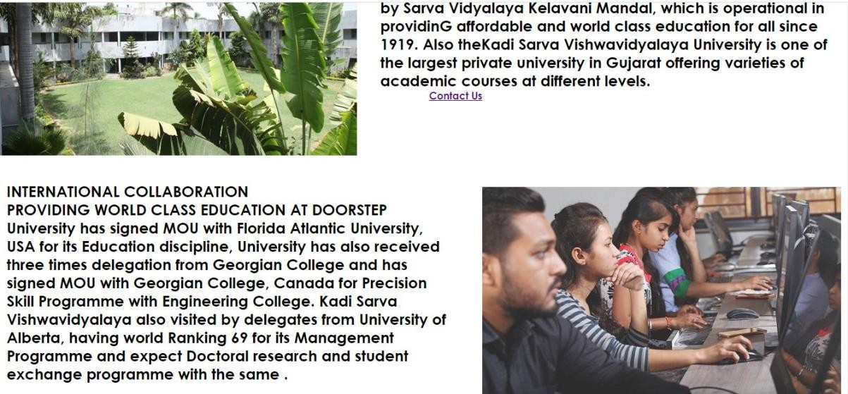

**Practical No. 10**

**Enrollment No.: 23becse54008**

**֍ Aim:**

**Make any logo and 5 PSD( Design) of Home page of website using Adobe Illustrator or Photoshop applying vectors and scalar , Filters etc**

**Output:**

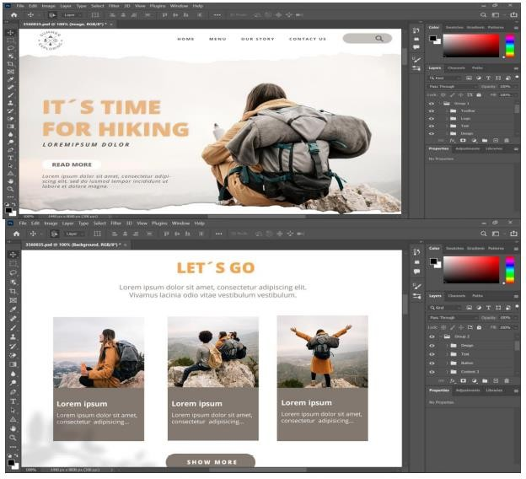



**Practical No. 11**

**Enrollment No.: 23becse54008**

**֍ Aim:**

**Develop a JavaScript to display today’s date.**

**Program:**

<html>

<head>

<title>Today's time</title>

</head>

<body>

<h3>Displaying Today's date and time</h3>

<button type="button" onclick="document.getElementById('time').innerHTML = startTime()"> Click here to display time</button>

<script>

function startTime(){

var today = new Date(); var h = today.getHours();

var m = today.getMinutes(); var s = today.getSeconds(); m = checkTime(m);

s = checkTime(s); document.getElementById("time").innerHTML = h + ":" + m + ":" + s; document.getElementById("time").innerHTML = Date();

var t = setTimeout(function(){startTime()},500);

**}**

function checkTime(i){ if(i<10){

i = "0" + i;

**}**

return i;

**}**

</script>

<p id="time"></p>

</body>

</html>

**Output:**

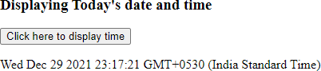

**Practical No. 12**

**Enrollment No.: 23becse54008**

**֍ Aim:**

**Develop simple calculator for addition, subtraction, multiplication and division operation using JavaScript**

**Program:**

<html>

<head>

<title> JavaScript Calculator </title>

<style>

input[type="button"]{ width:60px; background-color:black; color:white;}

input[type="text"]{ width:190px; background-color:black; color:white;}

</style>

<script>

function view(num)

**{**

document.getElementById("result").value+=num

**}**

function computer()

**{**

let x=document.getElementById("result").value let y=eval(x) document.getElementById("result").value=y

**}**

function clr()

**{**

document.getElementById("result").value=""

**}**

</script>

</head>

<body>

<center>

<h1 style="color:red">SIMPLE CALCULATOR</h1>

<table border="2">

<tr>

<td colspan="3"><input type ="text" id="result"></td>

<td><input type ="radio" value="c" onclick="clr()"> c </td>

</tr> <br>

<tr>

<td><input type = "button" value = "1" onclick = "view('1')"/> </td>

<td><input type = "button" value = "2" onclick = "view('2')"/> </td>

<td><input type = "button" value = "3" onclick = "view('3')"/> </td>

<td><input type = "radio" value = "/" onclick = "view('/')"/> / </td>

</tr>

<tr>

<td><input type = "button" value = "4" onclick = "view('4')"/> </td>

<td><input type = "button" value = "5" onclick = "view('5')"/> </td>

<td><input type = "button" value = "6" onclick = "view('6')"/> </td>

<td><input type = "radio" value = "-" onclick = "view('-')"/> - </td>

</tr>

<tr>

<td><input type = "button" value = "7" onclick = "view('7')"/> </td>

<td><input type = "button" value = "8" onclick = "view('8')"/> </td>

<td><input type = "button" value = "9" onclick = "view('9')"/> </td>

<td><input type = "radio" value = "+" onclick = "view('+')"/> + </td>

</tr>

<tr>

<td><input type = "radio" value = "." onclick = "view('.')"/> . </td>

<td><input type = "button" value = "0" onclick = "view('0')"/> </td>

<td><input type = "radio" value = "=" onclick = "computer()"/> = </td>

<td><input type = "radio" value = "*" onclick = "view('*')"/> * </td>

</tr>

</table>

</center>

</body>

</html>

# Output:

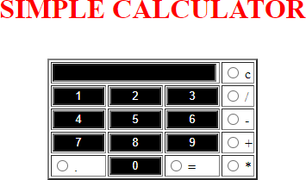

**Practical No. 13**

**Enrollment No.: 23becse54008**

**֍ Aim:**

**Create HTML Page with JavaScript which takes Integer number as input and tells whether the number is ODD or EVEN**

**Program:**

<html>

<head>

<script>

var number, temp; function fun()

**{**

number = parseInt(document.getElementById("num").value); if(number)

**{**

temp = document.getElementById("state"); temp.style.display = "block"; if(number%2==0)

**{**

document.getElementById("demo").innerHTML = myfun(number); document.getElementById("ans").innerHTML = "Even";

**}**

Else

**{**

document.getElementById("demo").innerHTML = myfun(number);

.getElementById("ans").innerHTML = "Odd";

**}**

**}**

**}**

function myfun(number)

**{**

return number;

**}**

</script>

</head>

<body>

<p>Enter the Number: <input id="num"><br>

<p style="margin:auto;"><p><button onclick="fun()">Check</button></p>

<p id="state" style="display:none;"><span id="demo"></span> is an

<span id="ans"></span> Number</p>

</body>

</html>

**Output:**

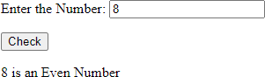

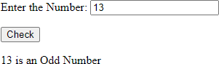

**Practical No. 14**

**Enrollment No.: 23becse54008**

**֍ Aim:**

**Create HTML Page that contains form with fields Name, Email, Mobile No,**

**Gender, Favourite Color and a button. Also write a JavaScript code to combine and display the information in textbox when the button is clicked.**.

**Program:**

<html>

<head>

<title>20BEIT54057 </title>

<script language="JavaScript"> function showInput()

**{**

document.getElementById('display').innerHTML = document.getElementById("user_name").value; document.getElementById('display1').innerHTML = document.getElementById("user_email").value; document.getElementById('display2').innerHTML = document.getElementById("user_password").value; document.getElementById('display3').innerHTML = document.getElementById("user_mobile").value; document.getElementById('display4').innerHTML =

document.querySelector('input[name="user_gender"]:checked').value; document.getElementById('display5').innerHTML

=document.getElementById("user_color").value;

**}**

</script>

</head>

<body bgcolor="skyblue">

<center>

<table>

<tr>

id="user_name"></br></br> id="user_email"></br></br>

<td>

<h2> REGISTRATION FORM </h2>

<form>

<b>NAME : <input type="text"

EMAIL : <input type="email" PASSWORD : <input

type="password"id="user_password"></br></br>

MOBILE NO : <input type="text"

id="user_mobile"></br></br>

GENDER : <input type ="radio"

name="user_gender"id="user_gender" value="male"/> male

<input type ="radio" name="user_gender" id="user_gender"value="female"/> female</br></br>

FAVOURITE COLOUR : <input type="text"

id="user_color"></br></br></b>

</form>

<input type="submit" onclick="showInput();"><br/>

<label>Your input is:</label>

<p><span id='display'></span></p>

<p><span id='display1'></span></p>

<p><span id='display2'></span></p>

<p><span id='display3'></span></p>

<p><span id='display4'></span></p>

<p><span id='display5'></span></p>

</td>

</tr>

</table>

</center>

</body>

</html>

**Output:**

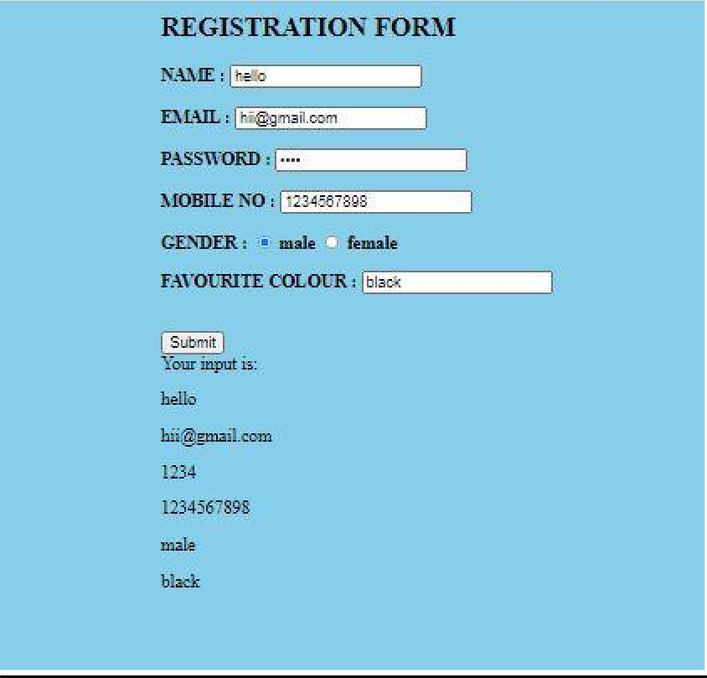

**Practical No. 15**

**Enrollment No.: 23becse54008**

**֍ Aim:**

**Write a JavaScript code to rotate images after a specific time interval**

**Program:**

<html>

<head>

<style>

#rotater {

transition: all 0.3s ease; border: 0.0625em solid black; border-radius: 3.75em; position:absolute;

top: 200px; left: 400px;

max-height: 300px; min-height: 300px; border: 2px solid red;

**}**

</style>

</head>

<body bgcolor="linear-gradient(90deg, #020024 0%, #090979 35%,#00d4ff

100%);">

<img id="rotater" onclick="rotate(this)" src="https://encrypted- tbn0.gstatic.com/images?q=tbn%3AANd9GcTmFWZQ1nPk8jPqCOh9EMAExXF2KCYK- laDrw&usqp=CAU"

style="transform: rotate(1440deg)">

<script type="text/javascript">

rotateAngle +"deg)");

let rotateAngle = 90; function rotate(image) {

image.setAttribute("style", "transform: rotate(" +

rotateAngle = rotateAngle + 90;

**}**

</script>

</body>

**</html> OUTPUT:**

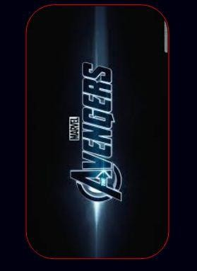

**֍ Aim:**

**Create an XML file and XML Schema to store student information like Enrolment Number, Name , Mobile Number and Email Id.**

**Practical No. 16 Enrollment No.: 23becse54008**

**Program:**

**<?xml version ="1.0"?>**

**<xsl:stylesheet version = "1.0" xmlns:xsl[="h](http://www.w3.org/1999/XSL/Transform)tt**[**p://www.w3.org/1999/XSL/Transform"**](http://www.w3.org/1999/XSL/Transform) **xmlns[="h](http://www.w3.org/TR/xhtml1/strict)tt**[**p://www.w3.org/TR/xhtml1/strict**](http://www.w3.org/TR/xhtml1/strict)**">**

**<xsl:template match = "/">**

**<h2><font aling="center" size=20px face=cooper> Student Information </font></h2>**

**<xsl:for-each select="students/student">**

**<br/>**

**<span style="font-weight:bold;color:black;font-family:cooper"> Name: </span>**

**<xsl:value-ofselect="name" /><br/><br/>**

**<span style="font-weight:bold;color:black;font-family:cooper"> Enrollment no: </span>**

**<xsl:value-ofselect="enrollment number" /> <br/><br/>**

**<span style="font-weight:bold;color:black;font-family:cooper"> Mobile no: </span>**

**<xsl:value-ofselect="mobile number" /> <br/><br/>**

**<span style="font-weight:bold;color:black;font-family:cooper"> Email Id: </span>**

**<xsl:value-ofselect="email id" /> <br/><br/>**

**</xsl:for-each>**

**</xsl:template>**

**</xsl:stylesheet>**

**Output:**

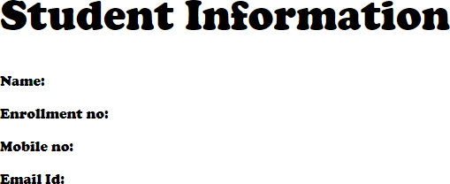

**Practical No. 17**

**Enrollment No.: 23becse54008**

**֍ Aim:**

**Create Document Type Definition (DTD) for above XML File.**

**Program:**

**<?xml version = "1.0"?>**

**<?xml-stylesheettype="text/css" href= "16.html"?>**

**<students>**

**<student>**

**<name><font face=cooper> ADITYA PATEL**

**</font></name><br><br>**

**<enroll><font face=cooper> 20BEIT30064 </font></enroll><br><br>**

**<phone><font face=cooper> 7698 72****</font></phone><br><br>**

**<email><font face=cooper>** [**aditya25@gmail.com**](mailto:aditya25@gmail.com)

**</font></email><br><br>**

**</student>**

**</students>**

**Output:**

ROHAN PATEL 20BEIT65035

9898 98****

[rohanpatel1000@gmail.com](mailto:rohanpatel1000@gmail.com)

**Practical No. 18**

**Enrollment No.: 23becse54008**

**23becse54008**

**֍ Aim:**

**Write a php program to check if number is prime or not.**

**Program:**

<?php

function check_prime($num)

**{**

if ($num == 1) return 0;

for ($i = 2; $i <= $num/2; $i++)

**{**

if ($num % $i == 0) return 0;

**}**

return 1;

**}**

$num = 263;

$flag_val = check_prime($num); if ($flag_val == 1)

echo "It is a prime number"; else

echo "It is a non-prime number"

**?>**

**Output:**



**Practical No. 19**

**Enrollment No.: 23becse54008**

**֍ Aim:**

**Create HTML page that contain textbox, submit / reset button. Write php program to display this information and also store into text file.**

**Program:**

<html>

<head>

<title>program_19</title>

<meta http-equiv="Content-Type" content="text/html; charset=UTF-8">

</head>

<body>

<form method='POST'>

<h2>Please input your name:</h2>

<input type="text" name="name">

<input type="submit" value="Submit Name">

<input type="reset" value="Reset Name">

</form>

<?php

**?>**

//Retrieve name from query string and store to a local variable

$name = $_POST['name'];

echo "<h3> Hello $name </h3>";

</body>

</html>

**Output:**

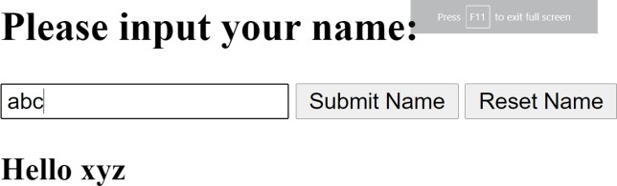

**Practical No. 20**

**Enrollment No.: 23becse54008**

**֍ Aim:**

**Write a php script to read data from txt file and display it in html table (the file contains info in format Name: Password: Email )**.

**Program:**

data.txt

[abc:123:abc@gmail.com](mailto:abc@gmail.com) [def:456:def@gmail.com](mailto:def@gmail.com) [xyz:789:xyz@gmail.com](mailto:xyz@gmail.com)

prac_20.php

<table>

<tr>

</tr>

<td>Name</td>

<td>Password</td>

<td>Email</td>

<?php

$file_handkler = fopen("data.txt","rb"); while(!feof($file))

**{**

$line_oftext=fgets($file);

$parts=explode(':',$line_of_text); echo"<tr><td>$parts[0]</td>

<td>$parts[1]</td>

<td>$parts[2]</td></tr>"

**}**

fclose($file);

**?>**

</table>

**Output:**

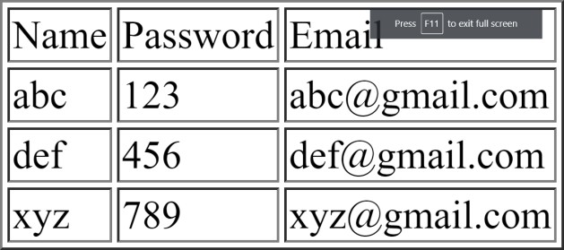

**Practical No. 21**

**Enrollment No.: 23becse54008**

**֍ Aim:**

**Write a PHP Script for login authentication. Design an html form which takes username and password from user and validate against stored username and**

**password in file**

**Program:**

<html>

<head>

<title>PHP login system</title>

// insert style.css file inside index.html

<link rel = "stylesheet" type = "text/css" href = "style.css">

</head>

<body>

<div id = "frm">

<h1>Login</h1>

<form name="f1" action = "authentication.php" onsubmit = "return validation()" method = "POST">

<p>

<label> UserName: </label>

<input type = "text" id ="user" name = "user" />

</p>

<p>

<label> Password: </label>

<input type = "password" id ="pass" name = "pass" />

</p>

<p>

<input type = "submit" id = "btn" value = "Login" />

</p>

</form>

</div>

// validation for empty field

<script>

function validation()

**{**

var id=document.f1.user.value; var ps=document.f1.pass.value;

if(id.length=="" && ps.length=="") {

alert("User Name and Password fields are empty"); return false;

**}**

else

**{**

if(id.length=="") {

alert("User Name is empty"); return false;

**}**

if (ps.length=="") { alert("Password field is empty");

return false;

**}**

**}**

**}**

</script>

</body>

</html>

# Output:

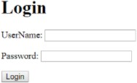

**Practical No. 22**

**Enrollment No.: 23becse54008**

**֍ Aim:**

**Write PHP Script for storing and retrieving user information from MySql table.**

1. **Design A HTML page which takes Name, Address, Email and Mobile No. From user (register.php)**
2. **Store this data in Mysql database / text file.**
3. **Next page display all user in html table using PHP ( display.php )**

**Program:**

connection.php

<?php

$host="127.0.0.1:3308";

$user="root";

$pass="";

$db="test";

$con=mysqli_connect($host,$user,$pass,$db); if ( mysqli_connect_errno() ) {

// If there is an error with the connection, stop the script and display the error. exit('Failed to connect to MySQL: ' . mysqli_connect_error());

**}**

**?>**

modified.php

<!DOCTYPE html>

<html>

<head>

<title>Insert Page page</title>

</head>

<body>

<center>

<?php

include "connection.php";

// Taking all 5 values from the form data(input)

$Name = $_REQUEST['Name'];

$Email = $_REQUEST['Email'];

$ContactNo = $_REQUEST['ContactNo'];

$Address = $_REQUEST['Address'];

// Performing insert query execution

$sql = "INSERT INTO itwpr22 VALUES ('$Name', '$Email','$ContactNo','$Address')";

if(mysqli_query($con, $sql)){

echo "<h3>data stored in a database successfully."

. " Please browse your localhost php my admin"

. " to view the updated data</h3>";

} else{

**}**

echo nl2br("\n$Name\n $Email\n "

. "$ContactNo\n $Address");

echo "ERROR: Hush! Sorry $sql. "

. mysqli_error($conn);

// Close connection mysqli_close($con);

**?>**

</center>

</body>

</html> prac_22.php

<!DOCTYPE html>

<html>

<head>

<title>Reg Form</title>

<style type="text/css">

.headercont{

font-family:Tahoma, Geneva, sans-serif; font-size: 70px;

color: #7CFF01; border-style: double;

**}**

input[type=text],textarea{ background-color: transparent; width: 95%;

color:white;

border-color: transparent;

**}**

input[type=text]:hover{

background-color: blue; border-color: transparent;

**}**

input[type=submit]{

width: 100%; color: white;

background-color: transparent;

**}**

input[type=submit]:hover{ background-color: #B2E3FB; color: black;

**}**

::placeholder{

color: white; opacity: 50%;

**}**

.regform{

font-family: Tahoma, sans-serif; font-size: 23px; color:white/*F3F315 39FF14*/; border-style: double;

border-radius: 3px; text-align: center;

**}**

.regform:hover{

border: hidden;

**}**

.reghead{

font-family:Tahoma, Geneva, sans-serif; font-size: 20px;

color: #0CF;

border-style: double; color: #FFFF00;

text-align: center;

**}**

.footercont{

font-family:Tahoma, Geneva, sans-serif; font-size: 30px;

color: #0CF;

border-style: double;

**}**

</style>

</head>

<body style="background-image: url(bg.jpg); background-size: cover; background-repeat: no-repeat;">

<header>

<table border="0" width="100%">

<tr>

<td width="100%" align="center" class="headercont">Registration Form</td>

</tr>

</table>

</header>

<article>

<form method="get" id="f1" action="modified.php">

<table border="0" width="30%" align="center">

<tr>

Form</td>

</tr>

<tr>

<td class="reghead" colspan="2">Registration

<td class="regform" width="27%">Name</td>

<td class="regform" width="73%"><input type="text"

placeholder="Enter your name" name="Name"></td>

</tr>

<tr>

<td class="regform" width="27%">Email</td>

<td class="regform" width="73%"><input type="text" placeholde[r="ex](mailto:myname@example.com):my[name@example.com"](mailto:myname@example.com) required name="Email"></td>

</tr>

<tr>

<td class="regform" width="27%">Contact No</td>

<td class="regform" width="73%"><input type="text"

placeholder="1234567890" pattern="[0-9]{10}" name="ContactNo" maxlength="10"></td>

</tr>

<tr>

<td class="regform" width="27%">Address</td>

<td class="regform" width="73%"> <textarea

rows="4" cols="50" name="Address" form="regform"> Enter your address here...</textarea></td>

</tr>

</table>

<table border="0" align="center" width="30%">

<tr>

<td class="regform" width="50%"><input type="submit" value="Cancel" formmethod="post" formtarget="blank"></td>

<td class="regform" width="50%"><input type="submit" value="Register" formmethod="get" formtarget="_parent" formnovalidate></td>

</tr>

<tr></tr>

</table>

</form>

</article>

<footer>

<table border="0" width="100%">

<tr></tr>

<tr>

<td width="100%" align="center" class="footercont">Copyright &copy; All Rights Reserved</td>

</tr>

</table>

</footer>

</body>

</html>

**Output:**



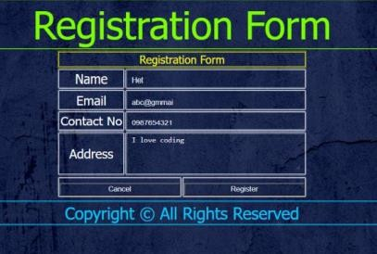

|  |  |  |
| --- | --- | --- |
|  | **Practical No. 23** | **Enrollment No.: 23becse54008** |
| **֍ Aim:**  **Create one blog website using wordpress, using different available plug-in (take free available theme) But, try to implement all the features of blog**  **website.** | | |

**Output:**

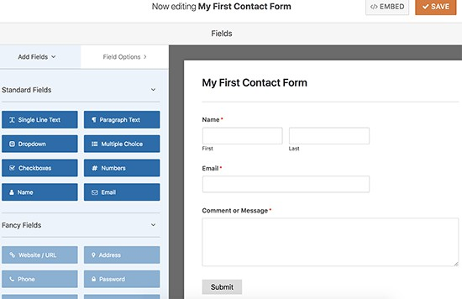

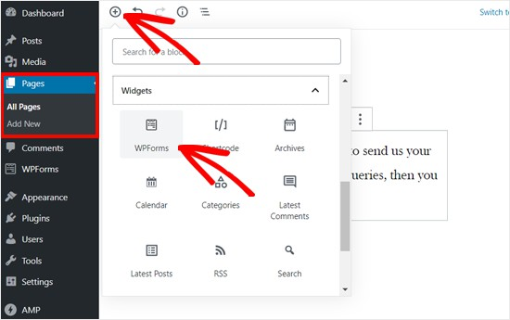

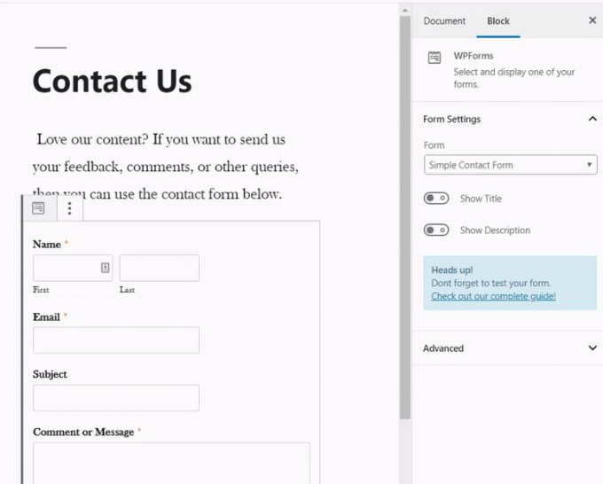

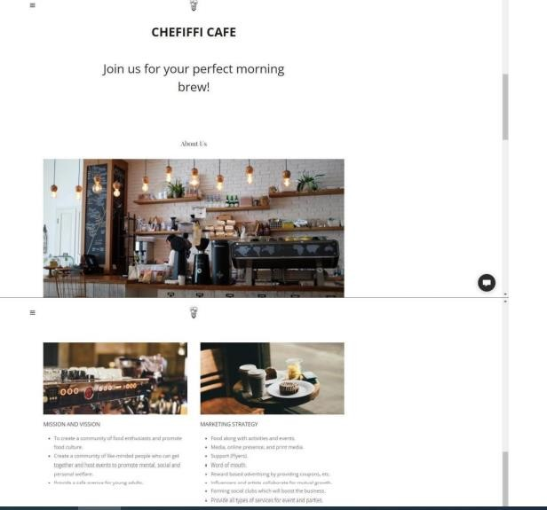

**Practical No. 24**

**Enrollment No.: 23becse54008**

**֍ Aim:**

**Implement the basic website structure using Code Ignitor Framewrok .**

**Program:**

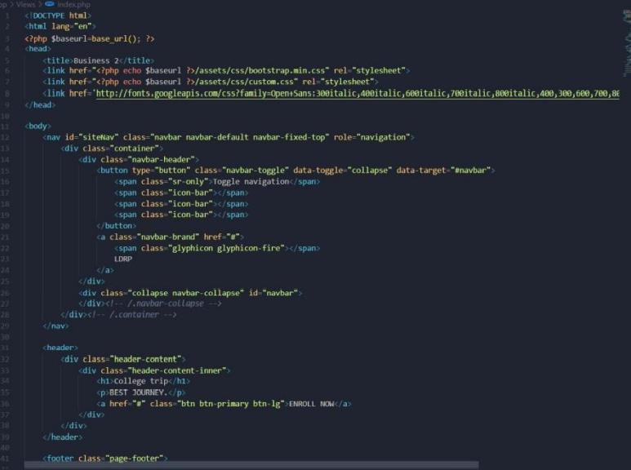



**Practical No. 25 Enrollment No.: 23becse54008**

**֍ Aim:**

**Using ajax fetch information from a database with AJAX.**

**fghggggg**

**fghhhhhhhffhfh**

**Program:**

Ajax.script.js

$(document).on('click','#showData',function(e){

$.ajax({

type: "GET",

url: "backend-script.php", dataType: "html", success: function(data){

$("#table-container").html(data);

**}**

**});**

**});**

Backend-script.js

<?php include("database.php");

$db=$conn;

// fetch query function fetch_data(){ global $db;

$query="SELECT * from usertable ORDER BY id DESC";

$exec=mysqli_query($db, $query); if(mysqli_num_rows($exec)>0){

$row= mysqli_fetch_all($exec, MYSQLI_ASSOC); return $row;

}else{

return $row=[];

**}**

**}**

$fetchData= fetch_data(); show_data($fetchData);

function show_data($fetchData){ echo '<table border="1">

<tr>

<th>S.N</th>

<th>Full Name</th>

<th>Email Address</th>

<th>City</th>

<th>Country</th>

<th>Edit</th>

<th>Delete</th>

</tr>';

if(count($fetchData)>0){

$sn=1;

foreach($fetchData as $data){

echo "<tr>

<td>".$sn."</td>

<td>".$data['fullName']."</td>

<td>".$data['emailAddress']."</td>

<td>".$data['city']."</td>

<td>".$data['country']."</td>

<td><a href='crud-form.php?edit=".$data['id']."'>Edit</a></td>

<td><a href='crud-form.php?delete=".$data['id']."'>Delete</a></td>

</tr>";

$sn++;

**}**

}else{

echo "<tr>

<td colspan='7'>No Data Found</td>

</tr>";

**}**

echo "</table>";

**}**

**?>**

data-list.php

<!DOCTYPE html>

<html>

<head>

<meta name="viewport" content="width=device-width, initial-scale=1">

</head>

<body>

<button id="showData">Show User Data</button>

<div id="table-container"></div>

<script src="https://ajax.googleapis.com/ajax/libs/jquery/3.4.1/jquery.min.js"></script>

<script type="text/javascript" src="ajax-script.js"></script>

</body>

</html> database.php

<?php

$hostname = "localhost";

$username = "root";

$password = "";

$databasename = "userdata";

// Create connection

$conn = mysqli_connect($hostname, $username, $password,$databasename);

// Check connection if (!$conn) {

die("Unable to Connect database: " . mysqli_connect_error());

**}**

**?>**

# Output:

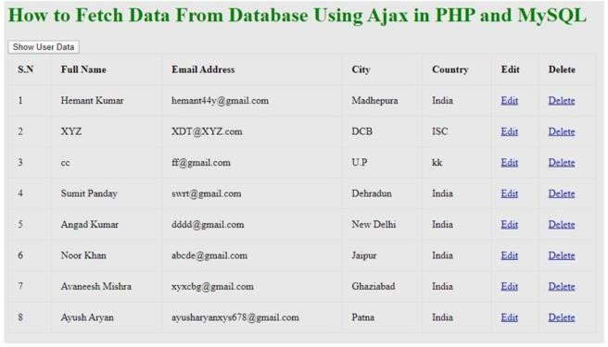

**Practical No. 26 Enrolment No.: 23becse54008**

**֍ Aim:**

**Install SciLab and get familiar with general environment and console**

**Output:**

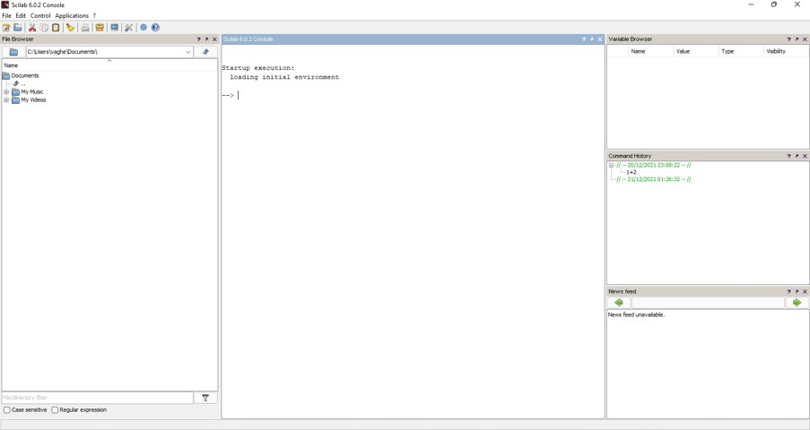

**Practical No. 27**

**Enrolment No.: 23Bbecse54008**

**֍ Aim:**

**Get simple mathematical/numerical operations executed in SciLab**

**Program:**

Startup execution: loading initial environment

1. **--> 1+2 ans= 3.**
2. **--> 2*3 ans =6.**
3. **--> 5%2**

5%2

**^~~^**

Error: syntax error, unexpected identifier, expecting end of file

1. **--> 2**5 ans =32.**
2. **--> 2^ 8 ans =256.**
3. **--> 90-1 ans = 78**

**Output:**

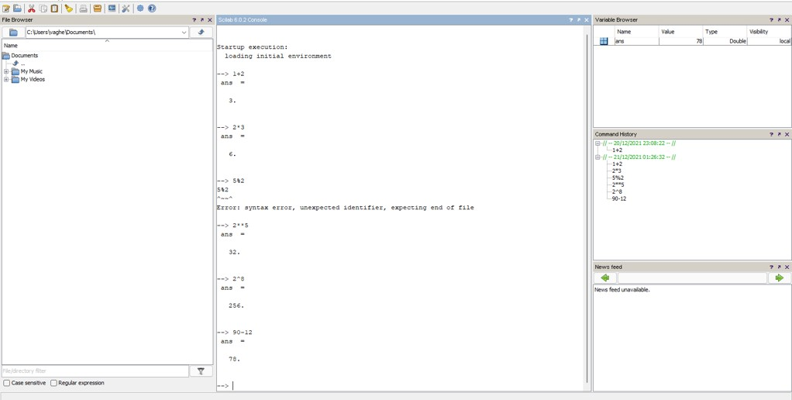

**Practical No. 28 Enrolment No.: 23becse54008**

**֍ Aim:**

**Plot curves/graphs using the graphics window**

**As part of experimentation, a small project / model / seminar / poster / other should be prepared / presented by student(s) based on the practical knowledge gained by this course at the end of the curriculum. The concerned laboratory faculty (in consultation with course coordinator) is empowered to design/decide the type/execution of this experiment. The student(s) are expected to present the same before their batch-mates**

**Program:**

function sinplot2(inital, final, N, v1, v2, v3) x1=linspace(inital,final,N) x2=linspace(inital,final,N) x3=linspace(inital,final,N) y=sin(2*%pi*v1*x1)

y1=sin(2*%pi*v2*x2) y2=sin(2*%pi*v3*x3) plot(x1,y,'O-r')

plot(x2,y1,'x-b')

plot(x3,y2,'*-g')

xlabel("x_axis(simple points"+string(N)+")") ylabel("f(x)=sin")

title('sin plot for different frequencies') endfunction

consol code:-

--> sinplot2(0,1,200,1,2,3)

**Output:**

